Deleting a fingerprint from the app
- First get your phone and open the app 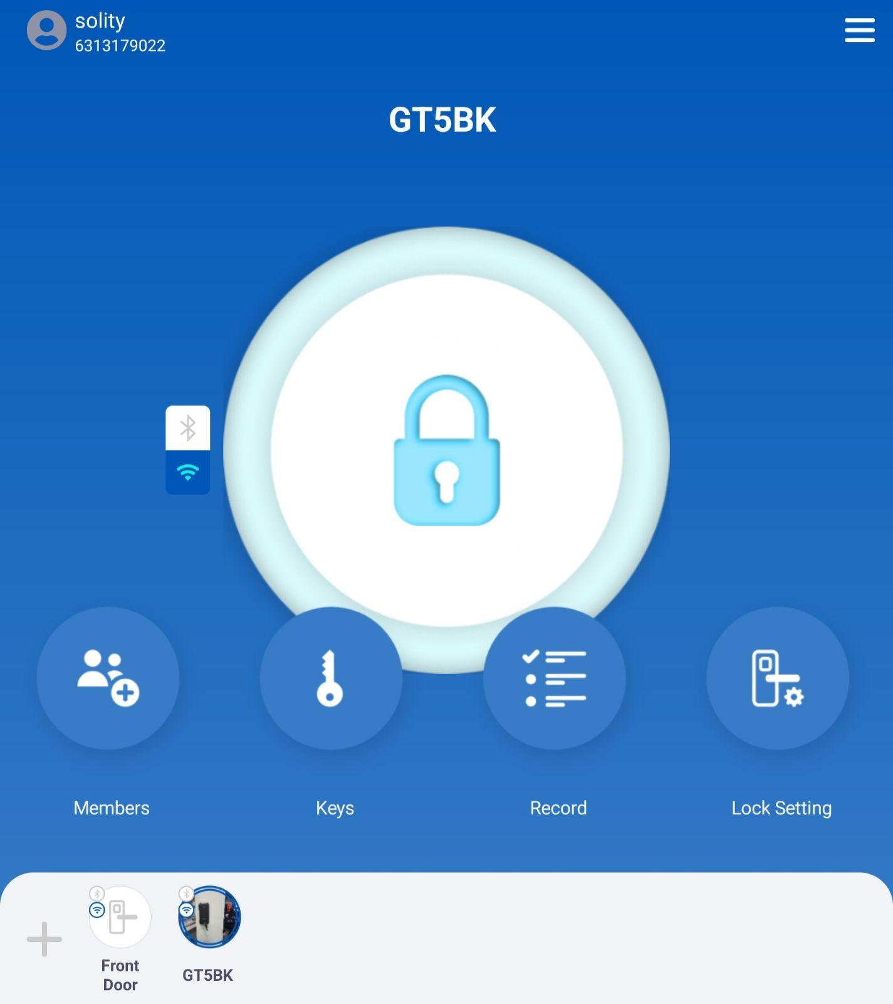
- If you have added multiple locks on the app, select the lock you want to delete the fingerprint from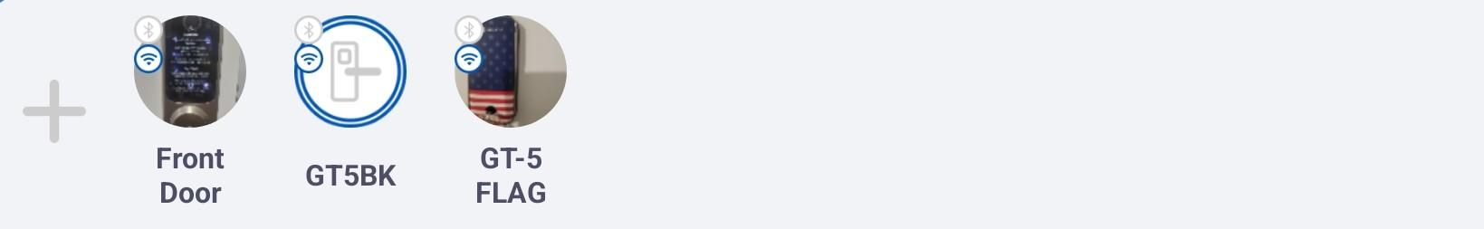
- Tap on the "Keys" icon 
- Select the fingerprint option 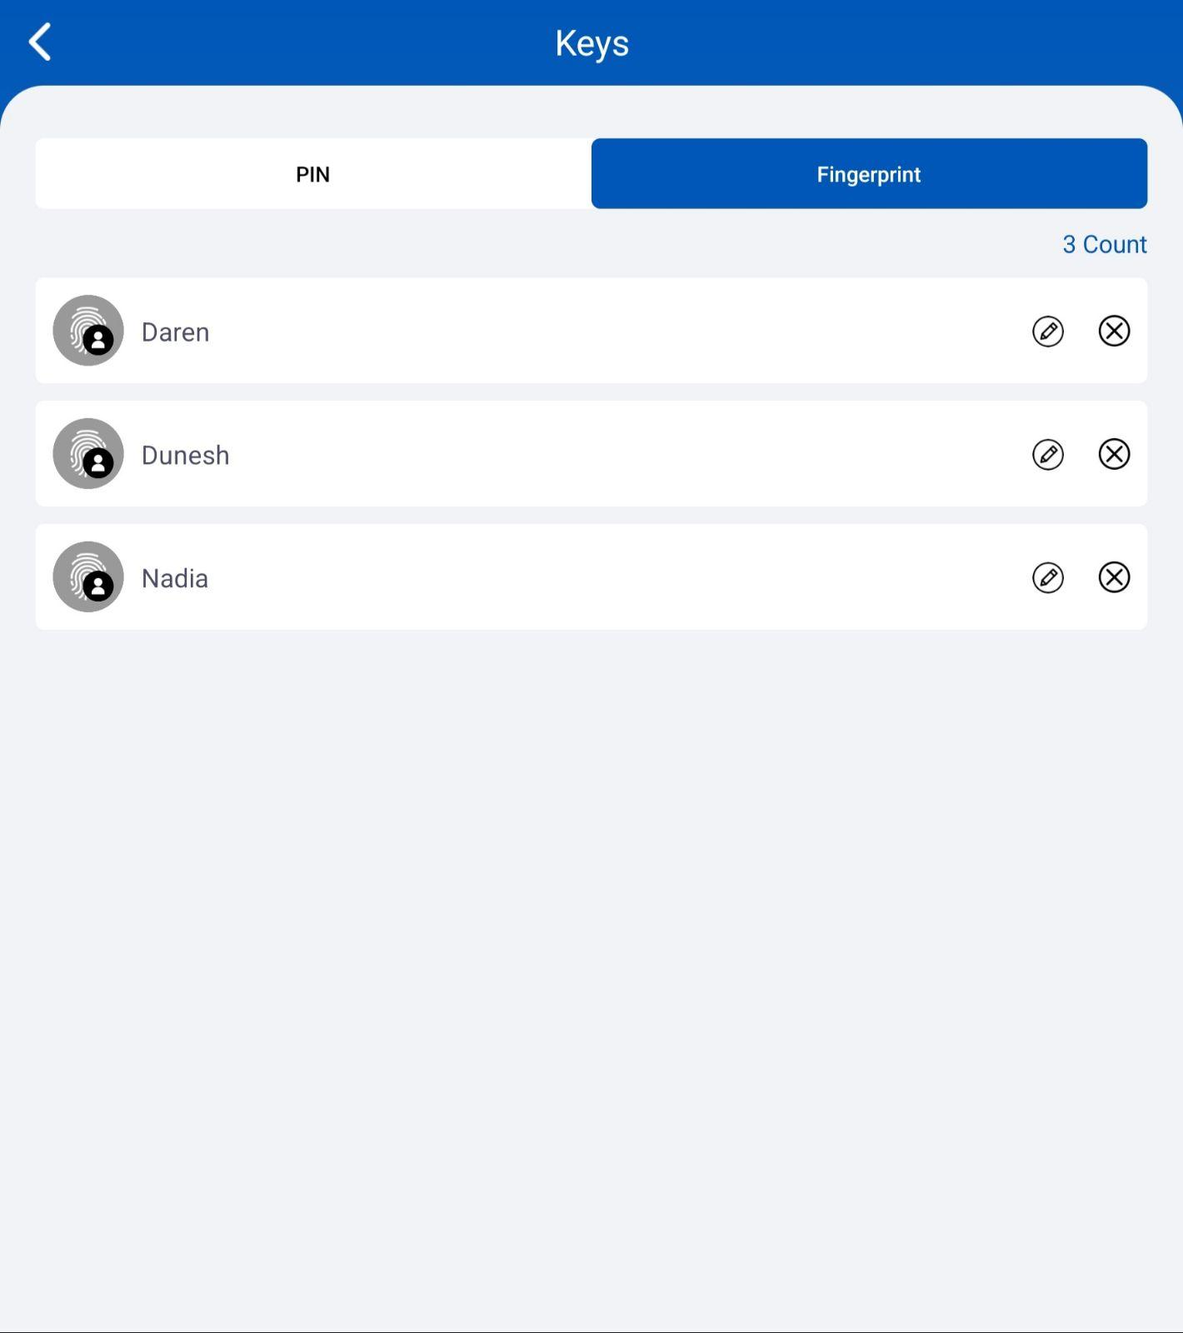
- Tap on the  that is on the right side of the persons fingerprint to delete the fingerprint

